(3 marks) You have main function which is saved on folder named Q1 already. Use these classes and functions to test all your operations in this question, DO NOT EDIT ANY CODE in main function. You can add more operations/classes/interfaces to be able to answer the below question.

Design and code a class named Food that holds information about a Food. Information of a Food includes:
- A string describes the name of a Food.
Include the following member functions in your design:
- Constructors to set values for instance variables.
- Add needed operations to the class.
Design and code a deriving class named Snack from Food class that holds information about a Snack. Information of a Snack includes:
- A whole value holding price of Snack.
- A String holding maker of Snack.
Include the following member functions in your design:
- Constructors to set values for instance variables.
- Add needed operations to the class so that the main function can be run and complete the below method which is declared in Snack class, the function will be used in second test case.
  - int getSalePrice() – this function return sales price of a Snack, sales price = price+ tax, where:
    - tax = 5 if maker starts with “D” or “d”
    - otherwise tax = 10
The program output might look something like:

No of test case | Correct output | Correct output
2 | 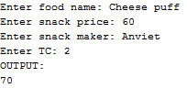 | 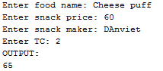
1 | 